Abstract
This paper proposes a unified approach to treat Fuzzy C-means (FCM) and K-means (KM) algorithms, organized in a general algorithm referred to as the Unified Form (UF) algorithm and proposes the Partitional Implementation of Unified Form (PIUF) algorithm. The UF algorithm is an element of novelty which was designed to facilitate the FCM and KM algorithms software implementation, and the PIUF form of the UF algorithm based on the MapReduce approach offers the possibility of implementing in a distributed manner the KM and FCM algorithms on a cluster of machines. This implementation solves in an elegant manner the challenges implied by processing large datasets in a sequential manner, ensuring scalability of the UF algorithm for processing any size dataset and overcoming any possible hardware limitations that can occur if large volumes of data are processed (required to be stored, loaded in memory and processed by a certain specified computational system). UF and PIUF algorithms are implemented and validated in BigTim platform, which is a distributed platform developed by the authors, and offers support for processing various datasets in a parallel manner. The Iris dataset is considered and next modified to obtain different datasets of different sizes in order to test the algorithms implementations in BigTim platform in different configurations. The analysis of the PIUF algorithm and BigTim platform is carried out using two performance indices.

Keywords: Distributed platforms; Fuzzy C-means algorithm; K-means algorithm; Partitional implementation; Unified form of fuzzy C-means algorithms and K-means algorithms.

3. Overview of Partition-based Clustering Algorithms
A partition-based clustering algorithm [1, 2, 17] divides a dataset in smaller parts of data called partitions. Each resulted partition contains records from the original dataset, which are similar each to other based on a specific metric. The main objective of a partition-based clustering algorithm is to create clusters of records that are formed by records that have high similarities but the inter-cluster similarities are maintained as low as possible. This is expressed as an appropriately defined optimization problem, and the clustering algorithm actually solves the problem in an iterative manner that provides the optimal centroids that correspond to an optimal set of clusters. Since a partition-based clustering algorithm is designed to provide a local optimum solution and not a global one, using different initial conditions can lead to different results.
BigTim platform is currently capable of running two clustering algorithms, namely FCM and KM. FCM algorithm assigns a dataset record to multiple clusters with a degree of fuzziness (e.g., soft clustering), and KM algorithm assigns a dataset record only to a single cluster (hard clustering).

3.1. Fuzzy C-means Algorithm
As shown in [9], FCM algorithm starts with the dataset D that consists of elements also called records or points, where a dataset record is defined as the vector x_{i}
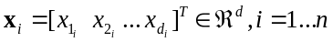, (1)
where d is the dimension of the vector x_{i} with the elements 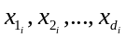, n is the total number of records of the dataset, and T stands for matrix transposition. The expression of the dataset is
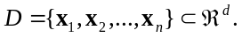, (2)
The algorithm consists in five steps that are performed in an iterative manner over the dataset until obtaining the final clusters defined as
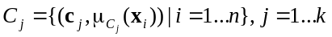, (3)
where k is the number of clusters, c_{j} is a centroid
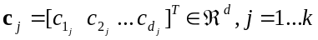, (4)
its elements are 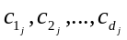, the total number k of centroids equals the number of clusters, 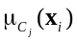 is the membership degree of point (or record or element) x_{i} to cluster C_{j}
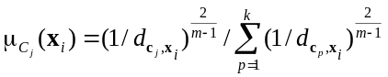, (5)
where m>1 is the fuzzification parameter, p, p=1...k, is the index of a centroid, and 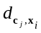 is the distance between record x_{i} and centroid c_{j}, defined as the metric
(6)
The centroids for all clusters are grouped in the centroid matrix c
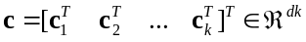. (7)
The main objective of FCM algorithm [14] is to minimize the intra-cluster variance, and it can be formulated in terms of the clustering problem expressed as the optimization problem
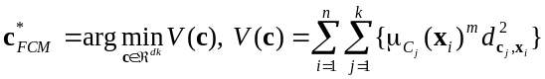, (8)
where c_{j} is the centroid of the cluster C_{j}, x_{i} is a dataset record defined in (1), 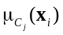 is the membership degree of point x_{i} to cluster C_{j}, and 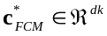 is the solution to optimization problem, also called the optimum centroid vector, with the general definition given in (7).
The general notation η will be used as follows for the current iteration of the algorithms, η=1...η_{max}, where η_{max} is the maximum number of iterations, which needs to be initialized. This notation will be inserted as the superscript (η) to point out the value of a vector or variable at a certain iteration of FCM algorithm.
The steps of FCM algorithm are FCM1 to FCM6:
Step FCM1. Initialize the iteration index η=1 and the number k of clusters.
Step FCM2. Initialize the centroid vector c⁽¹⁾, i.e., the initial value of the solution to (8)
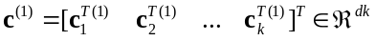. (9)
Step FCM3. Compute the distances 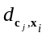 for each combination of records x_{i}, i=1...n, and centroids c_{j}, j=1...k, using (6).
Step FCM4. Build the membership matrix 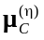
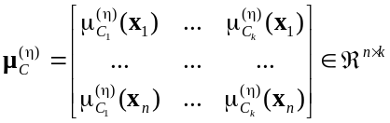, (10)
where the elements of the matrix, 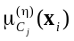, i=1...n, j=1...k, are computed in (5).
Step FCM5. Compute the new centroids used in the next iteration in terms of the following relationship:
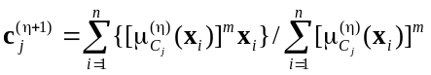, (11)
where j=1...k, and express the centroid vector used in the next iteration:
. (12)
Step FCM6. Test if FCM algorithm has found an optimal solution. The stopping criteria used to check if the algorithm has found a solution are composed by as pair of one inequality and one equality. The first stopping criterion checks that all centroid vectors are modified within a threshold with the width less than ε > 0 after two consecutive iterations. This first stopping criterion is expressed as the inequality
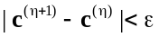. (13)
If the condition (13) is fulfilled, this means that the algorithm is complete and the solution to (8) is the last c^{(η+1)} obtained so far:
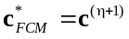. (14)
If the condition (13) is not fulfilled, it is checked if the second stopping criterion is fulfilled, i.e., the next equality is used which indicates that the maximum number of iterations is reached:
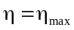. (15)
If the condition (15) is fulfilled, the algorithm is complete and the solution to (8) is given in (14). Otherwise, a new iteration will be performed, i.e., η is replaced with η+1 and the algorithm will continue with step FCM2.
The stopping criteria given in (13) and (15) are not the one generally ones used in FCM. In FCM the stopping criteria is assigned considering the maximum difference between the membership degrees of a certain point at a certain cluster obtained during the iteration and those obtained in the previous iteration. This different approach enables the unified formulation of both algorithms.
As pointed out in the classical papers [18, 34, 55], FCM algorithm is designed such that to solve the clustering problem expressed as the optimization problem defined in (8). The computation in accordance with (11) of the new centroids 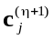 used in the next iteration and their grouping in (12) in the centroid vector c^{(η+1)} used in the next iteration will ensure the decrease of the value of the objective function V in (8) at each iteration. Therefore, the convergence of FCM algorithm to the solution 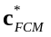 will be guaranteed.
Step FCM1 is an initialization step, and it is executed only once. The number of clusters k will remain constant along all iterations of the algorithm.
The initial choice of centroid vector c⁽¹⁾ is important. Different initializations of c⁽¹⁾ can cause different evolutions of FCM algorithm and make it converge to the same result but with different numbers of iterations.
Other elements of structures that belong to fuzzy modeling approaches can be used in combination with (10) as, for example, those presented in [3, 5, 7, 23, 39, 47, 49, 52]. However, elements of control systems [4, 6, 10, 33, 48] can be involved in this regard as systematic treatment is needed. In addition, the numerical solving of the optimization problem defined in (8) can be carried out using classical [8, 19, 42] or modern [44, 46, 50, 58] algorithms in combination with that presented in this sub-section.

3.2. K-Means Algorithm
As shown in [41], KM algorithm divides a dataset D defined in (2) consisting of the dataset records x_{i} defined in (1) in clusters by assigning every dataset point to only a single cluster (hard clustering). KM algorithm partitions the set of data points D into groups of points, each group having high intra-cluster similarities but maintaining low the inter-cluster similarities. The main objective of KM algorithm is formulated in terms of the clustering problem expressed as the optimization problem [13]
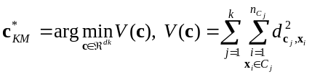, (16)
where 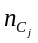, j=1...k, is the total number of records assigned to cluster C_{j}, 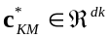 is the solution to optimization problem, also called the optimum centroid vector, with the general definition given in (7), and the other parameters are defined in Sub-section 3.1.
The steps of KM algorithm are KM1 to KM6:
Step KM1. Initialize the iteration index η=1 and the number k of clusters.
Step KM2. Initialize the centroid vector c⁽¹⁾ (the initial value of the solution to (16)) expressed in (9).
Step KM3. Compute the distances for each combination of records x_{i}, i=1...n, and centroids c_{j}, j=1...k, using (6).
Step KM4. All dataset records are assigned to one of the k clusters based on the distances calculated at step KM3. A record x_{i} is assigned to the cluster 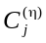 that has the centroid placed nearest to the record x_{i}:
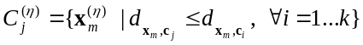. (17)
Once the dataset records are assigned to all k clusters, the total numbers 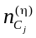 of records assigned to clusters are computed as the cardinals of the sets as
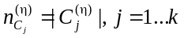. (18)
Step KM5. Compute the new centroids used in the next iteration in terms of the following relationship that gives the average values of all datasets records that belong to a certain cluster:
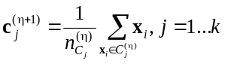, (19)
where j=1...k, and express the centroid vector c^{(η+1)} used in the next iteration using (12).
Step KM6. This step is identical to step FCM6 of FCM algorithm. If one or both stopping criteria expressed in (13) and (15) is/are fulfilled, the algorithm is complete and the solution to (16) is 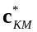
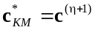. (20)
Otherwise, a new iteration will be performed, i.e., η is replaced with η+1 and the algorithm will continue with step KM2.
As highlighted in the classical papers [32, 43, 51], KM algorithm is designed such that to solve the clustering problem expressed as the optimization problem defined in (16). The computation in accordance with (19) of the new centroids used in the next iteration and their grouping in (12) in the centroid vector c^{(η+1)} used in the next iteration will ensure the decrease of the value of the objective function V in (16) at each iteration. Therefore, the convergence of KM algorithm to the solution will be guaranteed.

3.3. Unified Form of Fuzzy C-Means and K-means Algorithms
KM algorithm was analyzed in details in [36] to identify parts of the KM algorithm that can be parallelized. KM algorithm is similar to FCM algorithm. Both algorithms execute the same number of steps with similar operations to find the solutions to the clustering problems. The major difference between the algorithms is represented by the fact that FCM algorithm assigns a dataset record to multiple clusters with a degree of fuzziness; meanwhile KM algorithm assigns a dataset record only to a single cluster.
FCM and KM algorithms were designed to solve the clustering problems expressed as optimization problems described in (8) and (16), respectively. The following unified form of the clustering problems formulated as the optimization problems defined in (8) and (16) is proposed:
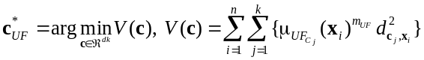, (21)
where 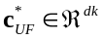 is the solution to optimization problem, also called the optimum centroid vector, with the general definition given in (7), the distances 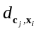 are computed using (6), 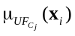 is the unified membership degree of point (or record or element) x_{i} to cluster C_{j}
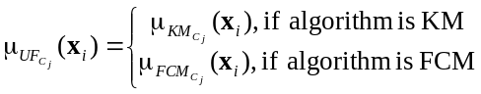, (22)
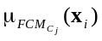 is the membership degree of point x_{i} to cluster C_{j} in case of FCM algorithm, computed based on (5) with m=m_{UF} as
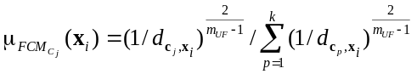, (23)
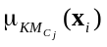 is the membership degree of point x_{i} to cluster C_{j} in case of KM algorithm, defined as
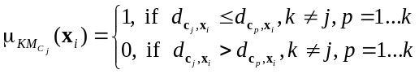, (24)
and m_{UF} is the unified fuzzification parameter, with the definition
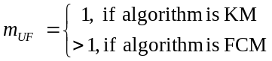. (25)
The unified form of the clustering and also optimization problem defined in (21) expresses both the clustering and optimization problem defined in (8) for FCM and the clustering and optimization problem defined in (16) for KM by using the parameterized value of the unified membership degree of point x_{i} to cluster C_{j} defined in (22) and the unified fuzzification parameter defined 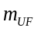 specific to FCM or to KM defined in (25). The justification for this unified form and unified clustering and optimization problem is in the fact that the solutions to the optimization problems defined in (8) and (21) are obtained as particular versions of the solution to the unified optimization problem defined in (21) in terms of the following relations for FCM:
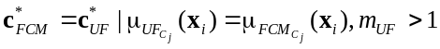, (26)
and KM:
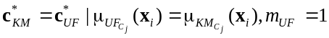. (27)
The unified form of the clustering problem expressed as the optimization problem defined in (21) is next used to implement a unified form of clustering algorithm, referred to as UF algorithm, which leads in particular to FCM and KM algorithms. The UF algorithm described in this sub-section reduces the effort required for the software implementation of FCM and KM algorithms as multiple parts are used by both algorithms being the same.
The steps of UF algorithm are UF1 to UF6:
Step UF1. Initialize the iteration index η=1 and the number k of clusters.
Step UF2. Initialize the centroid vector c⁽¹⁾ (the initial value of the solution to (21)) expressed in (9).
Step UF3. Compute the distances for each combination of records x_{i}, i=1...n, and centroids c_{j}, j=1...k, using (6).
Step UF4. Build the membership matrix 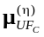
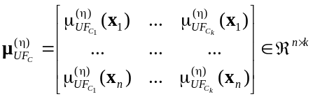, (28)
where the elements of the matrix, 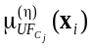, i=1...n, j=1...k, are computed using (22).
Step UF5. Compute the new centroids 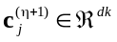 used in the next iteration in terms of the following relationship:
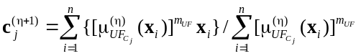, (29)
where j=1...k, and express the centroid vector c^{(η+1)} used in the next iteration and defined in (12).
Step UF6. This step is identical to step FCM6 of FCM algorithm. If one or both stopping criteria expressed in (13) and (15) is/are fulfilled, the algorithm is complete and the solution to (21) is 
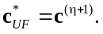 (30)
Otherwise, a new iteration will be performed, i.e., η is replaced with η+1 and the algorithm will continue with step UF2.
The above UF algorithm implementation results directly in FCM algorithm implementation or KM algorithm implementation by only particularizing (22).
As in the case of FCM and KM algorithms, using the unified form of the clustering expressed as the unified optimization problem defined in (21), the UF algorithm actually solves this optimization problem. In this regard the computation in of the new centroids 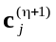 used in the next iteration and their grouping in (12) in the centroid vector c^{(η+1)} used in the next iteration will ensure the decrease of the value of the objective function V in (21) at each iteration. Therefore, the convergence of UF algorithm to the solution  will be guaranteed.

3.4. Partitional Implementation of Unified Form of Fuzzy C-Means and K-Means
As pointed out in Section 1, the processed dataset is next split in partitions. Each partition is processed in parallel by a single machine, which generates a partial result (that consists of local centroids), aggregated in a later step with the results obtained for the other partitions. The final result is represented by the global centroids [36].
Considering the unified form of FCM and KM algorithms, a point x defined in (1), n – the total number records in the dataset, D_{α}, α=1...λ – a partition of points, obtained by splitting the dataset in subsets with equal number of elements n_{p} – the number of records in a partition, n_{p} < n, where λ is the total number of partitions, computed as the integer part of n /n_{p}:
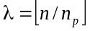. (31)
A partition D_{α} is a subset of the dataset D
. (32)
As illustrated in (32) and using (31), the partitions are generated using the order of records that is set in (1), and a number of (λ–1) partitions with n_{p} elements (records) will result. The last partition, namely D_{λ}, contains n – (λ–1)n_{p} elements. It is recommended to include all remaining elements in the last partition and not to create a new one because the processing time to retrieve the data for a new partition is higher than the required time to handle a partition with n – λn_{p} extra elements.
The partitional implementation of UF (PIUF) algorithm consists of seven steps that are applied in an iterative manner over the dataset D until the optimal solution defined in (21) is found. The steps of this partitional implementation of UF algorithm are PIUF1 to PIUF7:
Step PIUF1. Initialize the iteration index η=1, the number k of clusters, set the number λ of partitions, and split the processed dataset D in λ partitions D_{α}, α=1...λ, based on (31) and (32).
Step PIUF2. Initialize the centroid vector c⁽¹⁾ (the initial value of the solution to (21)) expressed in (9).
Step PIUF3. Process each existing partition D_{α}, α=1...λ, and compute the distances for each combination of records x_{i}, i=(α–1)n_{p}+1...αn_{p}+1 of a partition D_{α} and centroids c_{j}, j=1...k, using (6).
Step PIUF4. Build the membership matrix 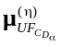 for all partitions D_{α}, α=1...λ:
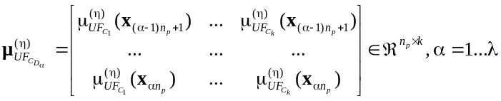, (33)
where the elements of the matrices , α=1...λ, are computed using (22).
Step PIUF5. Using the membership matrix , compute the partial centroids 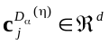 for all partitions D_{α}, α=1...λ
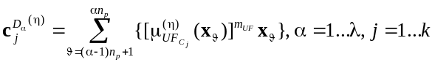, (34)
and the partial membership degree 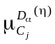 for all partitions D_{α}, α=1...λ
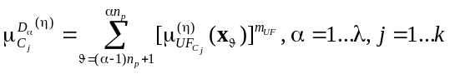. (35)
Step PIUF6. Compute the new global centroids
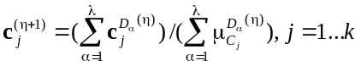. (36)
Step PIUF7. This step is identical to step UF6 of UF algorithm. If one or both stopping criteria expressed in (13) and (15) is/are fulfilled, the algorithm is complete and the solution described in (30) is obtained. Otherwise, a new iteration will be performed, i.e., η is replaced with η+1 and the algorithm will continue with step PIUF2.
The obtained global centroids obtained using the unified form of FCM and KM algorithms combined with the presented partitional implementation of unified form of FCM and KM algorithms actually produce the same centroids as those produced by the classical versions of FCM and KM algorithms. However, the software implementation constraints of UF algorithm (i.e., the way the number variables are stored in the memory of the machine, with a limited number of decimals) can lead to different solutions of UF algorithm and its partitional implementation. This difference occurs because the final centroids are computed in two steps and the accuracy can be affected due to the extra operations that are required. A practical situation encountered in this regard is if the value of the threshold in the stopping criteria is very low and also the maximum number of iterations η_{max} is very high.
All results reported in the framework of the above three directions outline the need to further improve the performance of clustering algorithms by running them in a distributed manner and also the importance of MapReduce approach. Therefore, the approaches suggested in this paper are fully justified.

4. BigTim Platform Architecture
The idea of a distributed platform was presented for the first time in [12] followed by a Map-Reduce implementation on a single machine in [14]. BigTim is a distributed platform, which is based on the parallel Map-Reduce implementation presented in [14] that allows for horizontal scalability if big datasets are processed. A high-level view of the platform architecture is presented in Fig. 1. The detailed architecture of BigTim platform is given in [11].
BigTim platform consists of three autonomous processes that are briefly described as follows:
- Partitioner process – it pre-processes the initial data by bringing it to a numerical form that can be processed (to avoid cases when the processed dataset is not purely numerical) and split the initial dataset into multiple partitions.
- Mapper process – it processes a partition and generates a partial result that can be post-processed by the Reducer process.
- Reducer process – it aggregates all outputs generated by all Mapper processes and generates the final result.
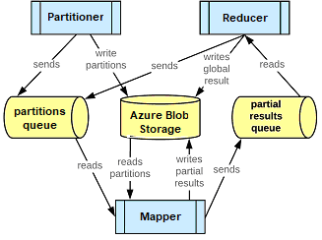

Fig. 1. Detailed architecture of BigTim platform.

The three processes communicate using Azure queue technology. Azure queue is used to facilitate the communication between two or more processes, some processes will write messages into a queue and others will read and process the messages from the queue. BigTim platform uses two queues for communicate between the processes. The first queue, referred to as partitions queue, is used by the Partitioner process or by the Reducer process to write a message into it, and the Mapper process reads and processes the messages in this queue. The second queue, called partial results queue, is used by the Mapper process to write messages and the Reducer process reads and processes the messages in this queue. Using Azure queue technology makes the platform subjected to easily horizontally scalability if big datasets are processed (by increasing the number of Mapper processes that work in parallel) and additional processing power is needed. Using Azure queue technology it is benefic for avoiding the race condition that can appear when multiple Mapper processes tries to processes the same partition in the same time. By using an Azure queue, only one Mapper process will have access to a message (with the details of the current processed partition) in the queue. Once a Mapper process extracts the message from the Azure queue, that message will not be anymore visible to the other Mapper processes ensuring that only one Mapper process accesses a partition at a certain moment of time. The processed partitions and the generated results are stored in Azure Blob Storage.
A processing cycle in BigTim platform consists of the following three steps, PC1 to PC3:
Step PC1. A processing cycle is triggered first time by the Partitioner process, which takes the initial dataset, splits it into partitions, writes the resulted partitions in Azure Blob Storage and sends a message to the partition queue for each newly created partition. The processing cycle can also be triggered by the Reducer process, which sends one message to the partition queue per each existing partition. The Reducer process will trigger a new processing cycle each time when the previous cycle is complete without obtaining the solution to the clustering problem.
Step PC2. The active Mapper processes monitor the partition queue, get the new messages from the queue and process the request. When the job performed by the Mapper processes is completed, new messages will be added by the Mapper processes to the partial result queue and the partial results generated by the Mapper processes will be dropped to the Azure Blob Storage.
Step PC3. The Reducer process gets all messages from the partial results queue, aggregates the data, generates the final results, writes the final results in the Azure Blob Storage and sends a new set of messages (one for each existing partition) to the partition queue to initialize a new processing cycle.

5. Experimental Setup
Different datasets were used to test the performance of the algorithms implemented in BigTim platform. These datasets were generated starting with the popular Iris dataset according to [22]. The Iris dataset contains information about different types of Iris plants structured as five attributes, the first four attributes represent predictive attributes and the last attribute represents the class of the Iris plant. The initial Iris dataset consists of 150 objects and can be split in three types of classes, each class further consisting of 50 dataset objects. The class distribution into this dataset is 33.3% for each of the three classes.
An important feature of this dataset is that the first class is linearly separable from the other two classes. However, the last two classes are not linearly separable each other.
The initial Iris dataset was used to create new datasets with different sizes. Five more datasets were created in a step-by-step manner by multiplying the records of the Iris dataset. Each of the newly created datasets is ten times bigger than that previously created dataset. For creating all the new datasets, each record of the initial Iris dataset was copied ten times, obtaining in the end a dataset with ten times more records, which will eventually result in the same results if FCM or KM algorithms are applied.
Existing records in the Iris dataset are multiplied and the existing items are not copied. That does not lead to multiple identical data t-uples in the dataset. In this regard, as shown in the next section, the huge amount of identical data t-uples do not distort the results of the algorithms. That is also the reason why an artificial dataset with known clusters centers and non-identical data t-uples is not generated and the localization of clusters elaborated with various methods is not compared.
The final results are the following datasets, which are made freely available by the authors at [31], they are named by the number of their records, and their brief description is:
- Iris-150 dataset, which is identical to the initial Iris dataset, it consists of 150 records, 3 types of object classes, and 50 instances of each object class. The dataset records are stored in a text file with a size of 5 kB.
- Iris-1500 dataset, with 1500 records, 3 types of object classes, and 500 instances of each object class. The dataset records are stored in a text file with a size of 46 kB.
- Iris-15000 dataset, with 15000 records, 3 types of object classes, and 5000 instances of each object class. The dataset records are stored in a text file with a size of 459 kB.
- Iris-150000 dataset, with 150000 records, 3 types of object classes, and 50000 instances of each object class. The dataset records are stored in a text file with a size of 4.88 MB.
- Iris-1500000 dataset, with 1500000 records, 3 types of object classes, and 500000 instances of each object class. The dataset records are stored in a text file with a size of 44.8 MB.
- Iris-15000000 dataset with 15000000 records, 3 types of object classes, and 5000000 instances of each object class. The dataset records are stored in a text file with a size of 448 MB.
The hardware configuration used in the experimental setup was composed by:
- Eight machines for running the Mappers, with Linux Ubuntu 16.04 operating system and the following hardware configuration: CPU Intel Core i5-7500, 3.4GHz quad-core, 16 GB of DDR3 RAM memory at 1600 MHz, 256 SSD.
- One machine for running the Reducer and the Partitioner, with Windows 10 operating system and the following hardware configuration: CPU Intel Core i7 4510U dual-core, 16 GB of DDR3 RAM memory at 800 MHz, 512 SSD hard drive.
The machines used for testing the algorithm performance were connected through a wired network with a limited internet connection of 100 Mb/s to each machine.

6. Experimental Results
Using the six datasets described in the previous section and available at [31], six scenarios were defined to test the performance of the algorithms implemented in BigTim platform and the behavior of the platform in processing datasets with different sizes. Each of the datasets described in Section 5 was processed 21 times, and the results are averaged in order to offer a fair presentation and comparison. For each processed dataset in each of the 21 processing times, the obtained clusters, membership matrices and final centroids were stored to compare the final results obtained for all 21 processing times.
Several numbers M_{processes} of Mapper processes were considered, 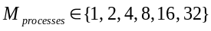. For each processed dataset different combinations of numbers of partitions and numbers of Mapper processes was used. Eight machines were used for running the Mapper processes, each of the machine having four cores available, with the maximum 32 individual Mapper processes that can run on those machines.
Six separate testing scenarios were conducted for all six datasets. For each possible number of Mapper processes, with the notation 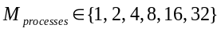, an initial number of partitions 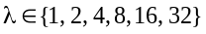 was chosen to equal the number of Mapper processes. After the dataset was completely processed, the number of the partitions was modified to the next possible value of λ until the value of 32 partitions was reached.
Choosing the number λ of partitions as 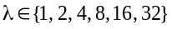, different partition sizes were obtained for all six processed datasets. The names of the partitions and their sizes are specified in Table 1 for all datasets.
The six scenarios are defined as follows, and their common feature is that just one Partitioner process and one Reducer process were used in each scenario:
Scenario 1. One Mapper process was used, i.e., 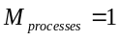. Each dataset was processed six times and divided in different numbers λ of partitions in each processing cycle. The number λ of partitions was considered as 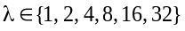. Different partition sizes were obtained for all six processed datasets.
Scenario 2. Two Mapper processes were used, i.e., 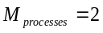. Each dataset was processed five times and divided in different numbers λ of partitions in each processing cycle. The number λ of partitions was considered as 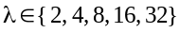.

Table 1
Partition names and sizes for different datasets and numbers of partitions
Number λ of partitions | Partition names and number n_{p} of elements in a partition
Number λ of partitions | Iris-150 | Iris-1500 | Iris-15000 | Iris-150000 | Iris-1500000 | Iris-15000000
1 | D₁, n_{p} = 150 | D₁, n_{p} = 1500 | D₁, n_{p} = 15000 | D₁, n_{p} = 150000 | D₁, n_{p} = 1500000 | D₁, n_{p} = 15000000
2 | D₁ and D₂,  n_{p} = 75 | D₁ and D₂,  n_{p} = 750 | D₁ and D₂,  n_{p} = 7500 | D₁ and D₂,  n_{p} = 75000 | D₁ and D₂,  n_{p} = 750000 | D₁ and D₂,  n_{p} = 7500000
4 | D₁, D₂ and D₃, n_{p} = 37, D₄,  n_{p} = 39 | D₁, D₂, D₃ and D₄, n_{p} = 375 | D₁, D₂, D₃ and D₄, n_{p} = 3750 | D₁, D₂, D₃ and D₄, n_{p} = 37500 | D₁, D₂, D₃ and D₄, n_{p} = 375000 | D₁, D₂, D₃ and D₄, n_{p} = 3750000
8 | D₁…D₇, n_{p} = 18, D₈, n_{p} = 24 | D₁…D₇, n_{p} = 187, D₈, n_{p} = 191 | D₁…D₈,  n_{p} = 1875 | D₁…D₈,  n_{p} = 18750 | D₁…D₈,  n_{p} = 187500 | D₁…D₈,  n_{p} = 1875000
16 | D₁…D₁₅, n_{p}=9,  D₁₆, n_{p} = 15 | D₁…D₁₅, n_{p}=93,  D₁₆, n_{p} = 105 | D₁…D₁₅, n_{p}=937,  D₁₆, n_{p} = 945 | D₁…D₁₆, n_{p}=9375 | D₁…D₁₆, n_{p}=93750 | D₁…D₁₆, n_{p}=937500
32 | D₁…D₃₁, n_{p}=4,  D₃₂, n_{p} = 26 | D₁…D₃₁, n_{p}=46,  D₃₂, n_{p} = 74 | D₁…D₃₁, n_{p}=468,  D₃₂, n_{p} = 492 | D₁…D₃₁, n_{p}=4687,  D₃₂, n_{p} = 4730 | D₁…D₃₂, n_{p}=46875 | D₁…D₃₂, n_{p}=468750

Scenario 3. Four Mapper processes were used, i.e., 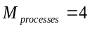. Each dataset was processed four times and divided in different numbers λ of partitions in each processing cycle. The number λ of partitions was considered as 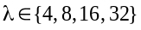.
Scenario 4. Eight Mapper processes were used, i.e., 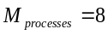. Each dataset was processed three times and divided in different numbers λ of partitions in each processing cycle. The number λ of partitions was considered as 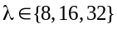.
Scenario 5. The number 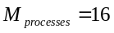 of Mapper processes was used. Each dataset was processed two times and divided in different numbers λ of partitions in each processing cycle. The number λ of partitions was considered as 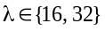.
Scenario 6. The number 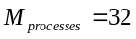 of Mapper processes was used. Each dataset was processed once and divided in different numbers λ of partitions in each processing cycle. The number λ of partitions was considered as .
The PIUF algorithm was applied in all six scenarios (1 to 6) defined above and implemented in BigTim platform in the particular form specific to FCM algorithm. The fuzzification parameter specific to PIUF algorithm was set to 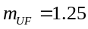. The maximum number of iterations was set to η_{max} = 100. The stopping criteria defined in (13) and (15) were used, with the value of ε set to ε = 0.00001.
The points of each dataset were associated in all six scenarios to the correct centroid of each of the processed dataset. The size of the dataset (for the datasets that were obtained by replicating the initial IRIS-150 dataset) did not modify the allocation of the points between the clusters. A number of 16 iterations were run to process all six datasets using the PIUF algorithm particularized to FCM algorithm, and this number of iterations was enough to obtain the solution to the clustering problem. The same initial centroids were used as a starting point in each performed cycle for each of the existing datasets. The algorithm converged to the same solution each time after the same number of 16 iterations.
Two main aspects are analyzed as follows. The first one is represented by monitoring how the number of partitions influences the processing time when the number of Mapper processes remains unchanged. The second aspect is to evaluate how the variation of the number of Mapper processes influences the processing time when the number of partitions remains unchanged.
The PIUF algorithm is designed to be faster than classical KM or FCM algorithm by processing the dataset in parallel. The processing time required for processing a dataset using PIUF algorithm decreases in a direct proportional manner with the number λ of partitions that are processed in parallel by multiple Mapper processes. BigTim platform is designed as a distributed platform where one or multiple Mapper processes run on a machine. For evaluating the PIUF algorithm implementation in BigTim platform considering a processed dataset D defined in (2) the performance index MP_{TimeRatio} is proposed and defined as follows:
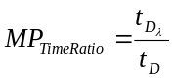, (37)
where 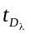 is the time needed to process a dataset divided in multiple partitions, and is the time needed to process the same dataset divided in the same number of partitions but processed independently by each existing Mapper processes. The value of this performance index indicates if processing the dataset in multiple partitions offers better time performance or not. The ideal value of MP_{TimeRatio} is 1; however, if the value of MP_{TimeRatio} is too high, this indicates that, for a particular dataset, BigTim platform will not produce good results if it will be processed in multiple partitions. The MP_{TimeRatio} performance index provides information on the performance of PIUF implementation in BigTim platform for different datasets.
Each scenario described above (1 to 6) was applied to all datasets (Iris-150 and all derived datasets from the initial Iris-150 dataset) to validate the suggested implementation of PIUF algorithm particularized to the FCM form. The scenario 1 was run six times for each of the Iris datasets. The scenario 2 was run five times for each of the Iris datasets. The scenario 3 was run four times for each of the Iris datasets. The scenario 4 was run three times for each of the Iris datasets. The scenario 5 was run twice for each of the Iris datasets. The scenario 6 was run once for each of the Iris datasets. After all six scenarios were conducted, each dataset was processed 21 times. Running the scenarios described above over all Iris datasets provided information on the processing time of the PIUF algorithm particularized to the FCM form run in different configurations, i.e., different numbers of Mapper processes, different ratios of numbers of Mapper processes-numbers of partitions, and different partition sizes. All clusters, membership matrices and final centroids obtained in these scenarios were identical in each of the 21 times when the dataset was processed, confirming that the PIUF implementation scales correctly and operates accordingly.

6.1. Experimental Results on Iris-150 Dataset
The Iris-150 dataset was processed 21 times; each processing cycle consisted in 16 iterations performed by the FCM algorithm. The recorded processing times from each cycle of the FCM algorithm are presented in Table 2.

Table 2
Processing time required for Iris-150 dataset measured in seconds
Number λ of partitions | Number M_{processes} of Mapper processes
Number λ of partitions | 1 | 2 | 4 | 8 | 16 | 32
1 | 13 | x | x | x | x | x
2 | 23 | 14 | x | x | x | x
4 | 45 | 26 | 18 | x | x | x
8 | 89 | 50 | 28 | 23 | x | x
16 | 166 | 89 | 48 | 36 | 35 | x
32 | 331 | 179 | 72 | 61 | 62 | 67

The results presented in Table 2 show that for a fixed number M_{processes} of Mapper processes, increasing the number λ of partitions leads to increasing the required time for processing the dataset. If λ is kept as a fixed parameter and M_{processes} is increased, Table 2 indicates that the required time for processing the dataset decreases.
The best time is obtained when only one Mapper process is used in association with only a single partition. This happens because the Iris-150 dataset has a relatively reduced size and the time required to manage the communication between the Mapper processes and Azure Blob Storage to retrieve the required data takes longer that the computing time required by each Mapper process to complete its job.
The values of MP_{TimeRatio} index obtained for Iris-150 dataset are presented in Table 3 for different values of M_{processes} and λ. Quite big values of MP_{TimeRatio} are observed in each case illustrated in Table 3, which suggests that BigTim platform is not suitable to process small datasets using the PIUF algorithm particularized to the FCM form.

Table 3
MP_{TimeRatio} for Iris-150 dataset
Number λ of partitions | Number M_{processes} of Mapper processes
Number λ of partitions | 1 | 2 | 4 | 8 | 16 | 32
1 | 1 | x | x | x | x | x
2 | 1.76 | 1 | x | x | x | x
4 | 3.46 | 1.85 | 1 | x | x | x
8 | 6.84 | 3.57 | 1.55 | 1 | x | x
16 | 12.76 | 6.35 | 2.66 | 1.56 | 1 | x
32 | 25.46 | 12.78 | 4 | 2.65 | 1.77 | 1

6.2. Experimental Results on Iris-1500 Dataset
The Iris-1500 dataset was processed 21 times; each processing cycle consisted in 16 iterations performed by the FCM algorithm. The recorded processing times from each complete cycle of the FCM algorithm are presented in Table 4.

Table 4
Processing time required for Iris-1500 dataset measured in seconds
Number λ of partitions | Number M_{processes} of Mapper processes
Number λ of partitions | 1 | 2 | 4 | 8 | 16 | 32
1 | 16 | x | x | x | x | x
2 | 24 | 15 | x | x | x | x
4 | 45 | 26 | 18 | x | x | x
8 | 89 | 49 | 28 | 25 | x | x
16 | 173 | 96 | 50 | 39 | 42 | x
32 | 349 | 198 | 95 | 71 | 66 | 65

The results presented in Table 4 show that for a fixed number M_{processes} of Mapper processes, increasing the number λ of partitions leads to increasing the required time for processing the dataset. If λ is kept as a fixed parameter and M_{processes} is increased, Table 4 indicates that the required time for processing the dataset decreases.
The best time is obtained when two Mapper processes are used in association with two partitions. This happens because the Iris-1500 dataset also has a relatively reduced size and the time required to manage the communication between the Mapper processes and Azure Blob Storage to retrieve the required data takes longer that the computing time required by each Mapper process to complete its job.
The values of MP_{TimeRatio} performance index obtained for Iris-1500 dataset are presented in Table 5 for different values of M_{processes} and λ. Once again, quite big values of MP_{TimeRatio} are observed in each case illustrated in Table 5, which suggests once more that BigTim platform is not suitable to process small datasets using the PIUF algorithm particularized to the FCM form.

Table 5
MP_{TimeRatio} for Iris-1500 dataset
Number λ of partitions | Number M_{processes} of Mapper processes
Number λ of partitions | 1 | 2 | 4 | 8 | 16 | 32
1 | 1 | x | x | x | x | x
2 | 1.5 | 1 | x | x | x | x
4 | 2.81 | 1.73 | 1 | x | x | x
8 | 5.56 | 3.26 | 1.55 | 1 | x | x
16 | 10.81 | 6.4 | 2.77 | 1.56 | 1 | x
32 | 21.81 | 13.2 | 5.44 | 2.84 | 1.57 | 1

6.3. Experimental Results on Iris-15000 Dataset
The Iris-15000 dataset was processed 21 times; each processing cycle consisted in 16 iterations performed by the FCM algorithm. The recorded processing times from each complete cycle of the FCM algorithm are presented in Table 6.

Table 6
Processing time required for Iris-15000 dataset measured in seconds
Number λ of partitions | Number M_{processes} of Mapper processes
Number λ of partitions | 1 | 2 | 4 | 8 | 16 | 32
1 | 20 | x | x | x | x | x
2 | 31 | 19 | x | x | x | x
4 | 52 | 34 | 20 | x | x | x
8 | 102 | 55 | 33 | 25 | x | x
16 | 173 | 101 | 52 | 38 | 39 | x
32 | 342 | 191 | 106 | 68 | 66 | 63

The results presented in Table 6 show that for a fixed number M_{processes} of Mapper processes, increasing the number λ of partitions leads to increasing the required time for processing the dataset. If λ is kept as a fixed parameter and M_{processes} is increased, Table 6 indicates that the required time for processing the dataset decreases.
The best time is obtained when two Mapper processes are used in association with two partitions. This happens because the Iris-15000 dataset has a relatively reduced size and the time required to manage the communication between the Mapper processes and Azure Blob Storage to retrieve the required data takes longer that the computing time required by each Mapper process to complete its job.
The values of MP_{TimeRatio} index obtained for Iris-15000 dataset are presented in Table 7 for different values of M_{processes} and λ. Comparing the current results with those obtained for Iris-150 and Iris-1500, an improvement of MP_{TimeRatio} is observed in each case illustrated in Table 7, i.e., the values of MP_{TimeRatio} for Iris-15000 are smaller for Iris-15000 with respect to those obtained for Iris-150 and Iris-1500. But the current dataset it is still a small size dataset and BigTim platform is not suitable to process small datasets using the PIUF algorithm particularized to the FCM form.

Table 7
MP_{TimeRatio} for Iris-15000 dataset
Number λ of partitions | Number M_{processes} of Mapper processes
Number λ of partitions | 1 | 2 | 4 | 8 | 16 | 32
1 | 1 | x | x | x | x | x
2 | 1.55 | 1 | x | x | x | x
4 | 2.6 | 1.78 | 1 | x | x | x
8 | 5.1 | 2.89 | 1.65 | 1 | x | x
16 | 8.65 | 5.31 | 2.6 | 1.52 | 1 | x
32 | 17.1 | 10.05 | 5.3 | 2.72 | 1.69 | 1

6.4. Experimental Results on Iris-150000 Dataset
The Iris-150000 dataset was also processed 21 times; each processing cycle consisted in 16 iterations performed by the FCM algorithm. The recorded processing times from each complete cycle of the FCM algorithm are presented in Table 8.

Table 8
Processing time required for Iris-150000 dataset measured in seconds
Number λ of partitions | Number M_{processes} of Mapper processes
Number λ of partitions | 1 | 2 | 4 | 8 | 16 | 32
1 | 94 | x | x | x | x | x
2 | 97 | 65 | x | x | x | x
4 | 127 | 89 | 50 | x | x | x
8 | 175 | 117 | 67 | 40 | x | x
16 | 261 | 173 | 135 | 62 | 46 | x
32 | 429 | 275 | 148 | 83 | 70 | 62

The results presented in Table 8 show that for a fixed number M_{processes} of Mapper processes, increasing the number λ of partitions leads to increasing the required time for processing the dataset. If λ is kept as a fixed parameter and M_{processes} is increased, Table 8 indicates that the required time for processing the dataset decreases.
The best time is obtained when eight Mapper processes are used in association with eight partitions. This happens because the Iris-150000 dataset has an average size and the time required to manage the communication between the Mapper processes and Azure Blob Storage to retrieve the required has decreased in comparison with previous processed datasets.
The values of MP_{TimeRatio} performance index obtained for Iris-150000 dataset are presented in Table 9 for different values of M_{processes} and λ. Comparing the current results with those obtained for Iris-150, Iris-1500 and Iris-15000, an improvement of MP_{TimeRatio} is observed again in each case illustrated in Table 9. This improvement is characterized by smaller values of MP_{TimeRatio} for Iris-150000 with respect to those obtained for Iris-150, Iris-1500 and Iris-15000. These results indicate that BigTim platform is suitable to process average size datasets using the PIUF algorithm particularized to the FCM form.

Table 9
MP_{TimeRatio} for Iris-150000 dataset
Number λ of partitions | Number M_{processes} of Mapper processes
Number λ of partitions | 1 | 2 | 4 | 8 | 16 | 32
1 | 1 | x | x | x | x | x
2 | 1.03 | 1 | x | x | x | x
4 | 1.35 | 1.36 | 1 | x | x | x
8 | 1.86 | 1.8 | 1.34 | 1 | x | x
16 | 2.77 | 2.66 | 2.7 | 1.55 | 1 | x
32 | 4.56 | 4.23 | 2.96 | 2.07 | 1.52 | 1

6.5. Experimental Results on Iris-1500000 Dataset
The Iris-1500000 dataset was processed 21 times; each processing cycle consisted in 16 iterations performed by the FCM algorithm. The recorded processing times from each complete cycle of the FCM algorithm are presented in Table 10.

Table 10
Processing time required for Iris-1500000 dataset measured in seconds
Number λ of partitions | Number M_{processes} of Mapper processes
Number λ of partitions | 1 | 2 | 4 | 8 | 16 | 32
1 | 665 | x | x | x | x | x
2 | 697 | 438 | x | x | x | x
4 | 735 | 480 | 348 | x | x | x
8 | 814 | 517 | 348 | 227 | x | x
16 | 1022 | 666 | 377 | 236 | 172 | x
32 | 1404 | 784 | 495 | 301 | 228 | 204

The results presented in Table 10 show that for a fixed number M_{processes} of Mapper processes, increasing the number λ of partitions leads to increasing the required time for processing the dataset. If λ is kept as a fixed parameter and M_{processes} is increased, Table 10 indicates that the required time for processing the dataset decreases.
The best time is obtained when 16 Mapper processes are used in association with 16 partitions. This happens because the Iris-1500000 dataset has a relative big size and the time required to manage the communication between the Mapper processes and Azure Blob Storage to retrieve the required has decreased significant in comparison with all previous processed datasets.
The values of MP_{TimeRatio} index obtained for Iris-1500000 dataset are presented in Table 11 for different values of M_{processes} and λ. Comparing the current results with those obtained for Iris-150, Iris-1500, Iris-15000 and Iris-150000, an improvement of MP_{TimeRatio} is observed again in each case illustrated in Table 11, i.e., the values of MP_{TimeRatio} for Iris-1500000 are smaller for Iris-1500000 with respect to those obtained for Iris-150, Iris-1500, Iris-15000 and Iris-150000. Thus, it is illustrated that BigTim platform is suitable to process big size datasets while providing very good results using the PIUF algorithm particularized to the FCM form.

Table 11
MP_{TimeRatio} for Iris-1500000 dataset
Number λ of partitions | Number M_{processes} of Mapper processes
Number λ of partitions | 1 | 2 | 4 | 8 | 16 | 32
1 | 1 | x | x | x | x | x
2 | 1.04 | 1 | x | x | x | x
4 | 1.1 | 1.09 | 1 | x | x | x
8 | 1.22 | 1.18 | 1 | 1 | x | x
16 | 1.53 | 1.52 | 1.08 | 1.03 | 1 | x
32 | 2.11 | 1.78 | 1.42 | 1.32 | 1.32 | 1

6.6. Experimental Results on Iris-1500000 Dataset
The Iris-15000000 dataset was also processed 21 times; each processing cycle consisted in 16 iterations performed by the FCM algorithm. The recorded processing times from each complete cycle of the FCM algorithm are presented in Table 12.

Table 12
Processing time required for Iris-15000000 dataset measured in seconds
Number of partitions λ | Number M_{processes} of Mapper processes
Number of partitions λ | 1 | 2 | 4 | 8 | 16 | 32
1 | 8258 | x | x | x | x | x
2 | 8302 | 4336 | x | x | x | x
4 | 8126 | 4602 | 3302 | x | x | x
8 | 8291 | 4761 | 3295 | 2051 | x | x
16 | 8199 | 4715 | 3336 | 2122 | 1682 | x
32 | 7867 | 4643 | 3252 | 2072 | 1691 | 1391

The results presented in Table 12 show that for a fixed number M_{processes} of Mapper processes, increasing the number λ of partitions leads to increasing the required time for processing the dataset. If λ is kept as a fixed parameter and M_{processes} is increased, Table 12 indicates that the required time for processing the dataset decreases.
The best time is obtained when 32 Mapper processes are used in association with 32 partitions. This happens because the Iris-15000000 dataset has a relative big size and the time required to manage the communication between the Mapper processes and Azure Blob Storage to retrieve the required has decreased significant in comparison with all previous processed datasets. The required time for managing the communication process becomes comparable to the time required for processing one partition by one Mapper process.
The values of MP_{TimeRatio} index obtained for Iris-15000000 dataset are presented in Table 13 for different values of M_{processes} and λ. Comparing the current results with those obtained for Iris-150, Iris-1500, Iris-15000, Iris-150000 and Iris-1500000, an improvement of MP_{TimeRatio} is observed again in each case illustrated in Table 13, i.e., the values of MP_{TimeRatio} for Iris-15000000 are smaller for Iris-15000000 with respect to those obtained for Iris-150, Iris-1500, Iris-15000, Iris-150000 and Iris-1500000. Thus, it is illustrated that the BigTim platform is suitable to process big size datasets while providing very good results using the PIUF algorithm particularized to the FCM form.

Table 13
MP_{TimeRatio} for Iris-15000000 dataset
Number of partitions λ | Number M_{processes} of Mapper processes
Number of partitions λ | 1 | 2 | 4 | 8 | 16 | 32
1 | 1 | x | x | x | x | x
2 | 1 | 1 | x | x | x | x
4 | 0.98 | 1.06 | 1 | x | x | x
8 | 1 | 1.09 | 0.99 | 1 | x | x
16 | 0.99 | 1.08 | 1.01 | 1.03 | 1 | x
32 | 0.95 | 1.07 | 0.98 | 1.01 | 1 | 1

